

Installation instructions for Hydroblock

Table des matières

Introduction 3

Installation 4

Step 1: Reception of the Hydroblock 4

Step 2: Selection of the location for the Hydroblock 4

Step 3: Securing the Hydroblock 5

Description of various connectors 6

1- Power Connector 7

2- NMEA0183 Connector 8

3- NMEA2000 Connector 9

1- SEATALK Connector 10

**Block Diagram of Connections 11**

**Electrical Diagram 12**

# Introduction

The Hydroblock is a self-contained hydrographic system that consists of a compartment housing a precision GNSS, an IMU and a sonar interface. These are necessary for the acquisition and processing of data related to bathymetric surveys, "i.e.," measurements of the ship’s position, attitude, and depth below its sonar. This guide outlines the necessary steps to properly install this technology into any vessel, and ensure optimal operating conditions.

# Installation

## Step 1: Reception of the Hydroblock

Upon receiving the Hydroblock, ensure that all necessary equipment for installation is available. Exact device details may vary according to model-specific configuration.

*Warning: The user should not have to open the compartment cover unless under supervision of CIDCO technicians*

1. Secure the Hydroblock by using the four screws in the corners, passing through the mounting brackets located at the ends of the device. Ensure that the arrow on the casing points toward the bow of the boat, as shown in Figure 1.
2. Connect the cable between the Hydroblock and the antenna securely. The cable end is shown in Figure 2.
3. Connect the cable between the Hydroblock and the sonar securely. The cable end is shown in Figure 2.
4. Connect the cable between the Hydroblock and the power securely.

## Step 2: Selection of the location for the Hydroblock

When installing the Hydroblock, it is essential to choose an appropriate location. To make this choice effectively, certain details must be taken into consideration.

1. The Hydroblock must be connected to a GNSS antenna to determine the GPS position of the sonar at all times. Therefore, it should be located at a distance less than the length of the antenna connection cable. The cable should be secured in a way that does not restrict the movement of the ship's crew. It is advisable to use clamps to ensure that the cable is not accidentally disconnected during bathymetric surveys.
2. The Hydroblock must be connected to a sonar to process its data. Therefore, it should be located at a distance less than the length of the sonar connection cable. The cable should be secured in a way that does not restrict the movement of the ship's crew. It is advisable to use clamps to ensure that the cable is not accidentally disconnected during bathymetric surveys.
3. The Hydroblock must be fixed in a way to have an appropriate orientation relative to the vessel to ensure accurate surveys. A marker on the Hydroblock (Figure 1), indicates the side that should be aligned with the boat's bow.
4. In cases where the equipment is configured to transmit data automatically to the CSB platform, it is important that the equipment is placed in an environment that does not limit WIFI or cellular connectivity.

## Step 3: Securing the Hydroblock

The Hydroblock is secured using 4 screws within the grooves on the compartment brackets. The following figure illustrates a proper installation of the Hydroblock.

## *Figure 1: Hydroblock*

# Description of various connectors

In the event of damage to any connector on the Hydroblock, this section provides instructions for their replacement.

*Figure 2 Example of Possible Connectors*

## Power Connector

*Figure 3: 'PIN LAYOUT' Power*

| PINS | Functions |
| --- | --- |
| A | Power Supply 12/24 V DC |
| B | GND (Negative Power) |
| C | Not Connected |

## NMEA0183 Connector

*Figure 4: 'PIN LAYOUT' NMEA0183*

| **NMEA0183 Connector** | |
| --- | --- |
| PINS | Functions |
| A | A+ RS485 |
| B | B- RS485 |
| C | GND |
| D | TX RS232 |
| E | RX RS232 |
| F | Power Supply 12/24 V |

## NMEA2000 Connector

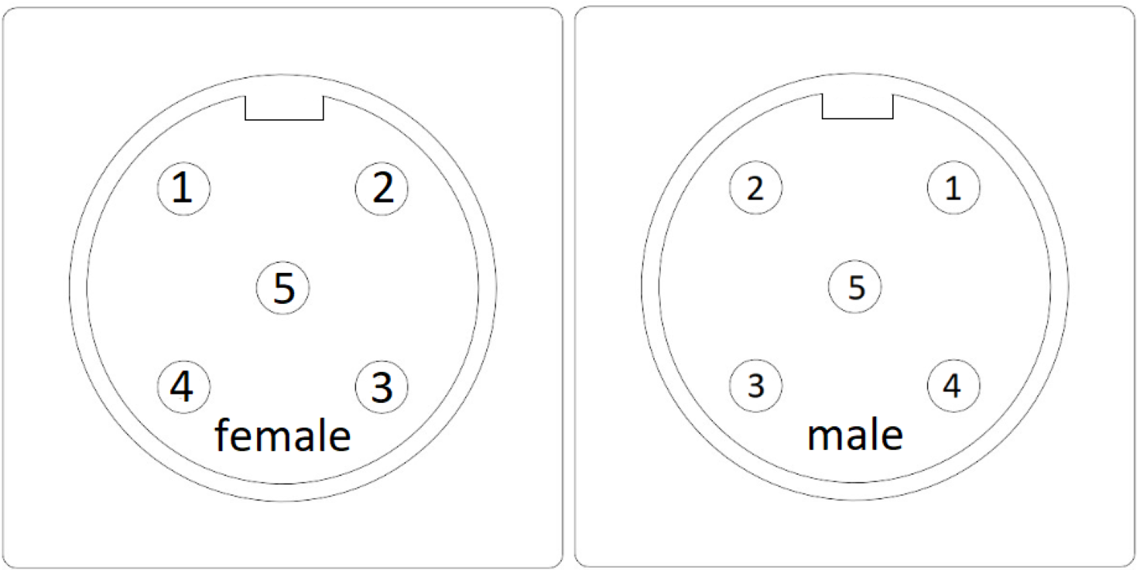

*Figure 5:'PIN LAYOUT' NMEA2000*

| **NMEA2000 Connector** | |
| --- | --- |
| PINS | Functions |
| 1 | Shield |
| 2 | 12V / NET-S |
| 3 | GND / NET-C |
| 4 | CAN-H / NET-Hi |
| 5 | CAN-L / NET-Lo |

## SEATALK Connector

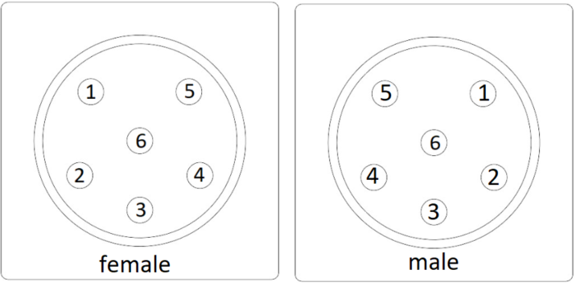

*Figure 6:'PIN LAYOUT' SEATALK*

| **SEATALK Connector** | |
| --- | --- |
| PINS | Functions |
| 1 | 12V |
| 2 | GND (0V) |
| 3 | SHIELD |
| 4 | CAN-L / NET-Lo |
| 5 | CAN-H / NET-Hi |
| 6 | SEATALK1 |

# Block Diagram of Connections

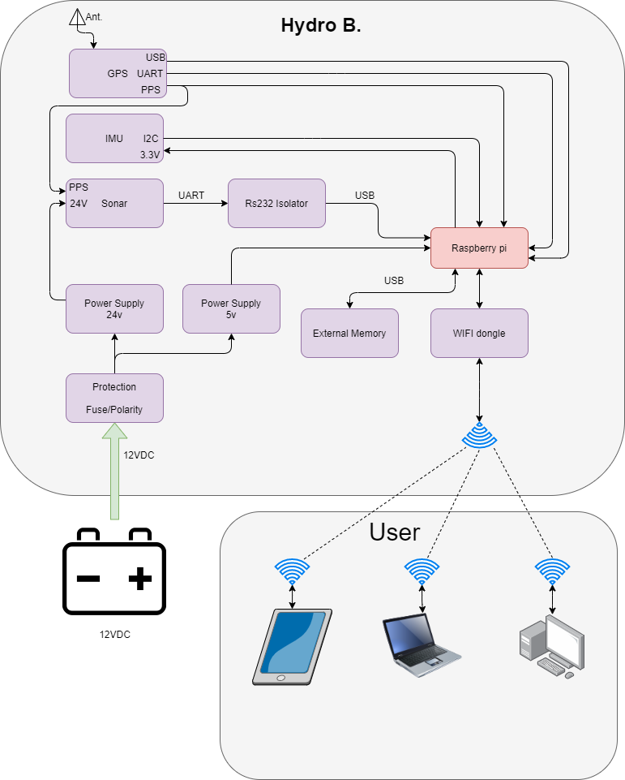

*Figure 7: Block Diagram of Connections*

# Electrical Diagram

*Figure 8 Electrical DIagram*